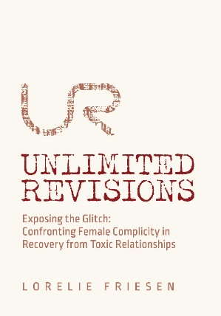

**Guided Journal Part ONE: “Getting to know Me”**

**Date:**

***FIRST:***

**CONGRATULATIONS!** You have taken an important step in your self-care. The commitment you are making to self-analysis will benefit many aspects of your life, particularly decision-making about relationships. UR is for women who have coped with toxic, abusive or dissatisfying relationships and the impact, which can be long-lasting in surprising ways. UR is for women seeking that elusive self-ove that immunizes from further harm. I congratulate you making this choice!

**This Week’s Mission:**

To spend time and energy on YOU.

To begin looking at your current/past circumstances (including stressors, family history and concerns about yourself and the relationships you have had)

To learn more about what experts define as toxic, abusive or healthy relationships

To identify questions you have about yourself

**Tools to help you:**

This guided journal

Someone to talk to

Reminders: you can do it! These answers are for YOU. This is the beginning of your letters to yourself!

Examples from the book **“UNLIMITED REVISIONS Exposing the Glitch” READ pages 11-13**

Articles (hyperlinks available)

**Why I am seeking change*:***

**I am concerned about my relationships (current and/or past):**

1. More about my current/past partners:

|  |  |  |
| --- | --- | --- |
| I have been with my current partner for: | Past partner: | (previous partners lumped together): |
| What I like about my current partner: | What I liked: |  |
| What I dislike: | Disliked: |  |

1. I have had the following relationships (please list partners, how long each relationship lasted, and how they ended):
2. My partner has a history of family dysfunction or difficulty that which I feel causes him difficulty in relationships:

|  |  |  |
| --- | --- | --- |
| Current partner (describe, if applicable): | Past partner: | Previous partners lumped together: |
|  |  |  |

1. I love my partner (current, past, other) and try to be there for him by listening, encourage him to address any personal difficulties (true or false?):
2. I fear my current or previous relationship is/was toxic (read 2 Giving In on Everything (glitch narrowly defined).pdf):

The relationship contributed to my self-esteem, emotional energy

The relationship damaged my self esteem, drained energy

My partner attempted to isolate me from family and friends to limit support and increase dependence on the relationship

Our relationship seemed to be based on arguments and negativity. My partner was often berating, belittling, and putting me down or criticizing my attempts to do anything positive or independent.

My partner blamed me for any negative things and events in our relationship.

My partner often accused me of flirting or dating or having a sexual relationship with someone else. Ironically, my partner flirted, dated or had sexual relationships with others.

my partner denied issues and recreated history of events to put him/herself in a better light.

I usually gave in on everything, even things I found morally, personally or ethically objectionable just to keep my partner happy.

1. I fear my current or previous relationship is/was abusive (read Coercive control can be a life or death issue in relationships. But few people even know how to recognize it - The Globe and Mail.pdf):

My partner is/was physically/sexually violent: hitting, pinching, slapping, throwing, choking, raping, etc.

My partner brandished anger: made a fist, threatened, punched holes in walls, throwing objects, etc.

my partner barraged me with texts or calls when I was out

My partner was critical of my clothes, appearance

my partner called family and friends when he could not reach me

my partner damaged property (such as my car) to prevent me from leaving, or clothes to prevent me from wearing them.

My partner withheld finances, assets (such as car, phone, other necessities) cutting off support if I left or if (s)he suspected I was planning to leave.

1. I sense my relationship is/was dissatisfying for me and/or my partner:

I don’t feel it was reciprocal – I gave more than I got (to the household, to my partner and to the nurturing and repairing of the relationship when there was conflict)

my partner paid more attention to his friends or hobbies or ex-es than to me

I felt insecure in the relationship, like it could end at any time, with any small mistake I made

I yearned for more intimacy (closeness, togetherness, affection), not necessarily sexual intimacy. I yearned for more one-on-one time with my partner

**I am concerned about my circumstances:**

STRESSORS:

1. My circumstances include the following medical issues (include mental health, substance use/abuse):
   1. Myself –
   2. My partner –
   3. My kids/step-kids/parents/others –
2. The following legal issues:
   1. Myself –
   2. My partner –
   3. My kids/step-kids/parents/others
3. The following financial issues:
   1. Myself –
   2. My partner –
   3. My kids/step-kids/parents/others –
4. The following sexual/intimacy issues:
   1. Myself –
   2. My partner –
5. Family income and social status:

My partner and I contribute two incomes to the household and we live comfortably

If not, describe:

1. How my partner and I deal with the stressors and resolve conflicts (indicate to which partner these apply):

We communicate regularly with respect and with little conflict

There is silence, neither of us broaching difficult subjects. I try not to talk about stressors or issues, I try to avoid the conflict.

There is name-calling, shouting, profanity when we try to discuss stressors.

If other, describe:

**I am concerned about myself:**

I feel stuck, I have held myself back from pursuing goals, dreams (describe):

I have not attended to my medical, physical, spiritual, emotional needs or family/friends because I give my energy to my partner and/or relationship, the household, the kids and other stressors

I have been in more than one abusive/toxic/dissatisfying relationship

I have returned to an abusive/toxic/dissatisfying relationship (either once, or repeatedly) even though I knew the relationship would not improve

I find myself falling for the same kind of partner (people with criminal records, suspended licenses, addictions, limited means or resources). My friends and I joke about how I seem “to attract” certain partners, or how I “am attracted” to them.

I willingly give my resources (time, money, expertise) to my partner. Even if my resources are scarce, I give to my partner, who is less willing or able to reciprocate. I inconvenience myself and/or my kids (describe):

Because of my concerns, I am accessing professional counselling services, etc. (describe):

I have a history of adverse childhood experiences (ACEs) [Fast Facts: Preventing Adverse Childhood Experiences |Violence Prevention|Injury Center|CDC](https://www.cdc.gov/violenceprevention/aces/fastfact.html) . ACEs are potentially traumatic events between the ages of 0-17 years including:

experiencing violence, abuse, neglect

witnessing violence in the home

having a family member die by suicide

illness, death of a parent

Also the following aspects of an environment that undermine a sense of safety, stability and bonding, such as growing up in a household with:

substance use problems

mental health problems

instability due to parental absence/separation, moving around a lot, or a household member being in jail/prison

*a stressed mom – one who dealt with living with a toxic, abusive partner; community upheaval (such community violence, fleeing another country, living through a war)

*prematurity, lots of invasive medical procedures requiring separation from mom

*you are adopted

*circumstances that can negatively impact parent-child attachment (Gabor Mate, 1999)

Others:

bullying

teen dating violence

witnessing community violence

Other trauma or circumstance from childhood, adolescence or adulthood not listed above, that you believe is relevant (describe):

**I am beginning to think it’s all about me:**

I ask myself: “Why do I keep doing this?” “Why am I like this?” “How did I get here (again)?” “What is it about me that keeps me in a mean marriage/relationship?” “What is it about me that keeps me stuck?”

These **Questions that Drive Seeking** signal readiness to change your trajectory. To shift your focus away from solving your partner’s (or parent’s) issues, addictions, family drama/trauma. Away from trying to fulfill their needs, calm their temper. Real change comes when you shine a light on your own repetitive thoughts and behaviors that cause you to continue to choose *more of the same.*

Personally, after asking these questions, I began to think I had a glitch in my thinking that caused me to repeat my errors.

1 What is the GLITCH (broadly defined).pdf

Notes:

Questions I want to ask:

(Next: Workshop #1 “ENTER”)



**Guided Journal Part TWO –**  **“Getting Ready to EXCAVATE”**

**Date:**

**This Week’s Mission:**

Identify repetitive thoughts and behaviors in relationships

Identify things you do to distract you from “The Sad”, stay in denial

Begin YOUR PATHWAY

Identifying circumstances that NEGATIVELY impact your feelings of worthiness. These are sources of Sadness/Shame and *REPETITION*.

Link them to emotions you have been avoiding.

Allow yourself to feel them, contemplate and acknowledge the role they play in your life and decisions around relationships.

Go deeper, find your inner little girl and her broken heart. To the adolescent or adult, her experiences, things done or left undone

Find self-compassion

**Tools to Help you:**

Reminders and optional reading assignments (links to articles)

Lorelie’s examples **READ UNLIMITED REVISIONS p. 25-28 (“The Sad”)**

Lorelie’s lessons **Read UNLIMITED REVISIONS pages 267-269**

YOUR PATHWAY, populated with the circumstances

**What thoughts/behaviors have I repeated in relationships?** (consider current or past relationships)

My examples: add your comments if any of my examples resonate with you!

*‘schmuckful’ thoughts -* (these are romantic, fantastical “but I love him”, “he is trying to change”, etc.), straight out of Harelequin Romances or your favorite Rom Com where the heroine finds out that her love-interest’s past is the reason for his poor behavior, and he manages to squeak out a “win”, he prevails and persuades the heroine to drive off into the sunset with him (supposedly to their happily-ever-after ending). Shortly thereafter, the romance and the comedy are done…….

*‘ the chasing’* – you find out your partner is flirting or starting a new relationship so you panic and chase. Or you fear being alone with your sadness, so you chase. This includes doing up your hair and make-up whenever you suspect you will encounter your partner.

*‘the “what-if”….’ -* Fantasizing about your partner’s capacity to chase you, become a “knight in shining armor”, to see any small gesture he makes as a HUGE DEAL, meaning you should reconcile…..

*‘the paddling hard’* – whenever something goes wrong (a miscommunication, missed appointment, forgetting something, children are in conflict) you work hard to make it better, repair the situation, over-apologizing, sending notes, texts assuming all the blame, minimize the impact so your partner will not “lose his shit”.

*‘the smoothing over’* - you minimize a partner’s outburst, take the blame for their tantrum, and turn a blind eye to damaged property, threats or brandishing anger. You encourage your children to do the same. You offer sex to ‘soothe the savage beast’ that is your partner. (my friend “D” calls this *‘the sugar-coating’)* (my friend “L” calls this *‘pimping myself out’)*

*‘tippy-toe’ –* when your partner is seething, you and the children move quietly and quickly so as not to disturb that savage beast. (my friend “L” calls this *‘eggshells’).*

*‘drunk texting’* – your sadness causes you to overindulge and send text barrages to your partner that, the next morning, you really regret. (my friend “P” has done this, and has had relationships with partners who also barraged her).

*‘caving’* – when you need to have a crucial, respectful conversation with your partner, you avoid it because you fear it will end badly. You do this even when your partner (who may be a new, more patient, loving, kind partner) can be trusted to actually have a crucial, respectful conversation.

*‘catastrophizing’* -you assume the worst reaction from your partner. You even contemplate running away, ending a relationship because of the story you tell yourself.

*‘denial’* – you “solider on” as though nothing has happened. You forge ahead, focus on the positive things in your life.

YOUR OWN EXAMPLES: “Name it to Change it!”

All of the above are dissatisfying responses that rob you of wholehearted living and healthy relationships.

Your fierce, inner drag queen would tell you: “Girl! You have a (bleeping) glitch!”

Your GLITCH has been EXPOSED!

On to the 4E’s of Recovery! 3 what are the 4E's.pdf

Most of us work hard to avoid our feelings of sadness or shame. Check off things you do to avoid:

Make a plan with a friend or loads of friends, the bigger the party the better

Call up a friend or family member to talk (usually about the latest incident with your partner or ex)

Call up your partner, or ex, to meet, talk or reunite.

Tell your counsellor you have hope for your (hopeless) relationship. “He is trying to change, he swears he will change, he is working on ‘it’”.

Start dating other people (“attracting” the same kind of partner as your old partner)

Work overtime

housework, cleaning and organizing the home, the garden, the office, etc.

start volunteering, getting involved in new activities, including your child’s teams/lessons

getting involved in other people’s drama

working out (morning and/or night)

spend all your time online, to avoid any “daydreaming”

use substances (including prescription meds, THC, CBD) so you don’t have to “think”, so you can sleep instead

focus energy on my partner, writing letters to him, to myself, ranting about the latest incident (his temper or his “floosies” or exposing our children to harm).

binge-watch, binge-eat, binge-shop

List any others:

Describe what you think is the source of your “sad.” What is it you are trying to avoid?

acknowledging childhood circumstances or adverse childhood experiences, including being abandoned, and fearing being alone, fearing the dark

the end of a relationship, loss of connection, good memories make me sad

thoughts of children being exposed to harm while they are with my ex

fear I’m missing out on fun, family times while children are with my ex

feeling unworthy of love or belonging

List any others:

UR pathway – reminders and optional reading assignments:

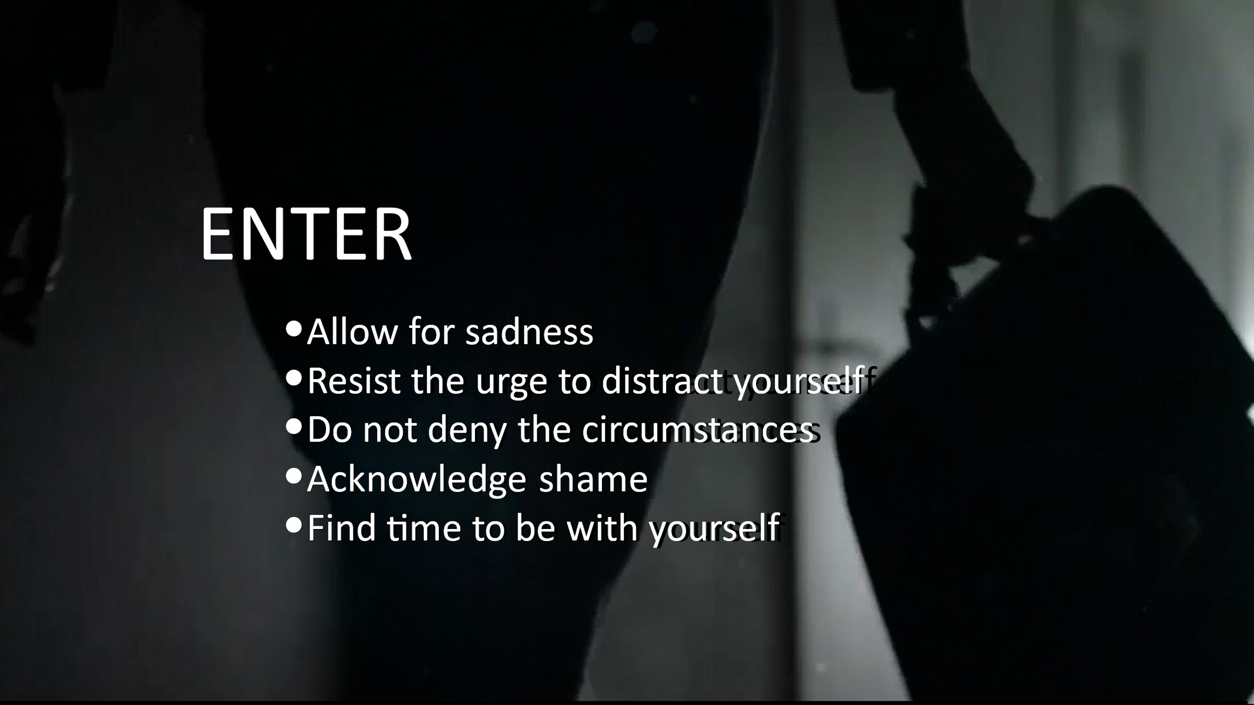

**1st E - ENTER the swamp (of sadness, of shame):** The hardest of the 4E’s.

Feelings of Sadness are natural, especially when navigating an abusive, toxic or dissatisfying relationship. Or when contemplating difficult circumstances, including the end of a relationship.

**Read p. 25-30, 55** **in UNLIMITED REVISIONS**

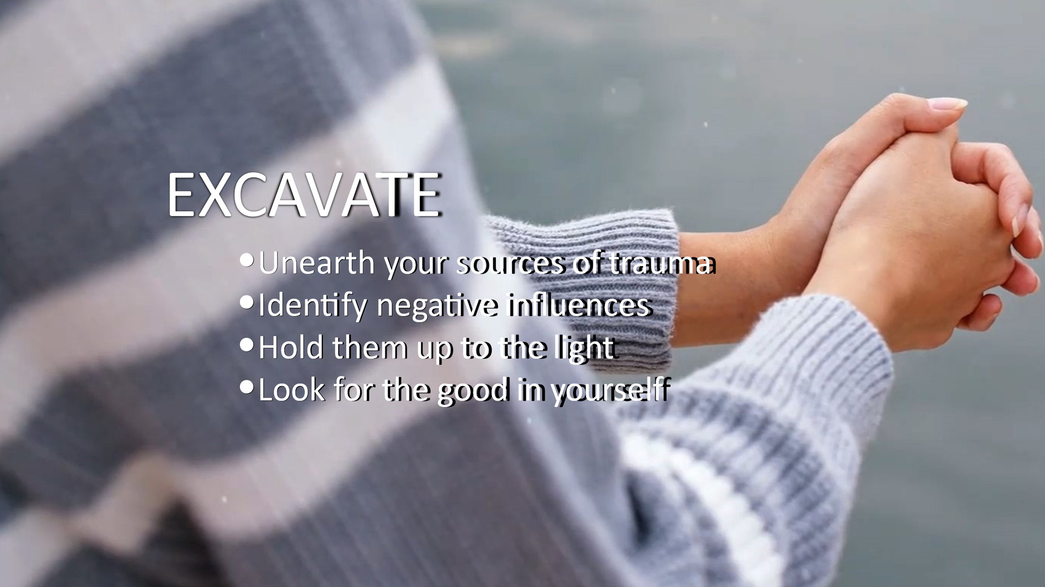**At our next meeting (#2 EXCAVATE) we will begin to link circumstances and emotions.**

**2nd E – EXCAVATE circumstances:** It is a universal human trait: preferring to keep the sadness, and its cause (circumstances) BURIED. You have started the tough work of Excavating the Circumstances at the root of Sadness/Shame in Part One of your journal (“Getting to Know Me”). Hold them up to the light and consider your inner child or adolescent in them. Your feelings of sadness are justified.

**Read p. 73-75**

**Meeting #3 is EXAMINE:**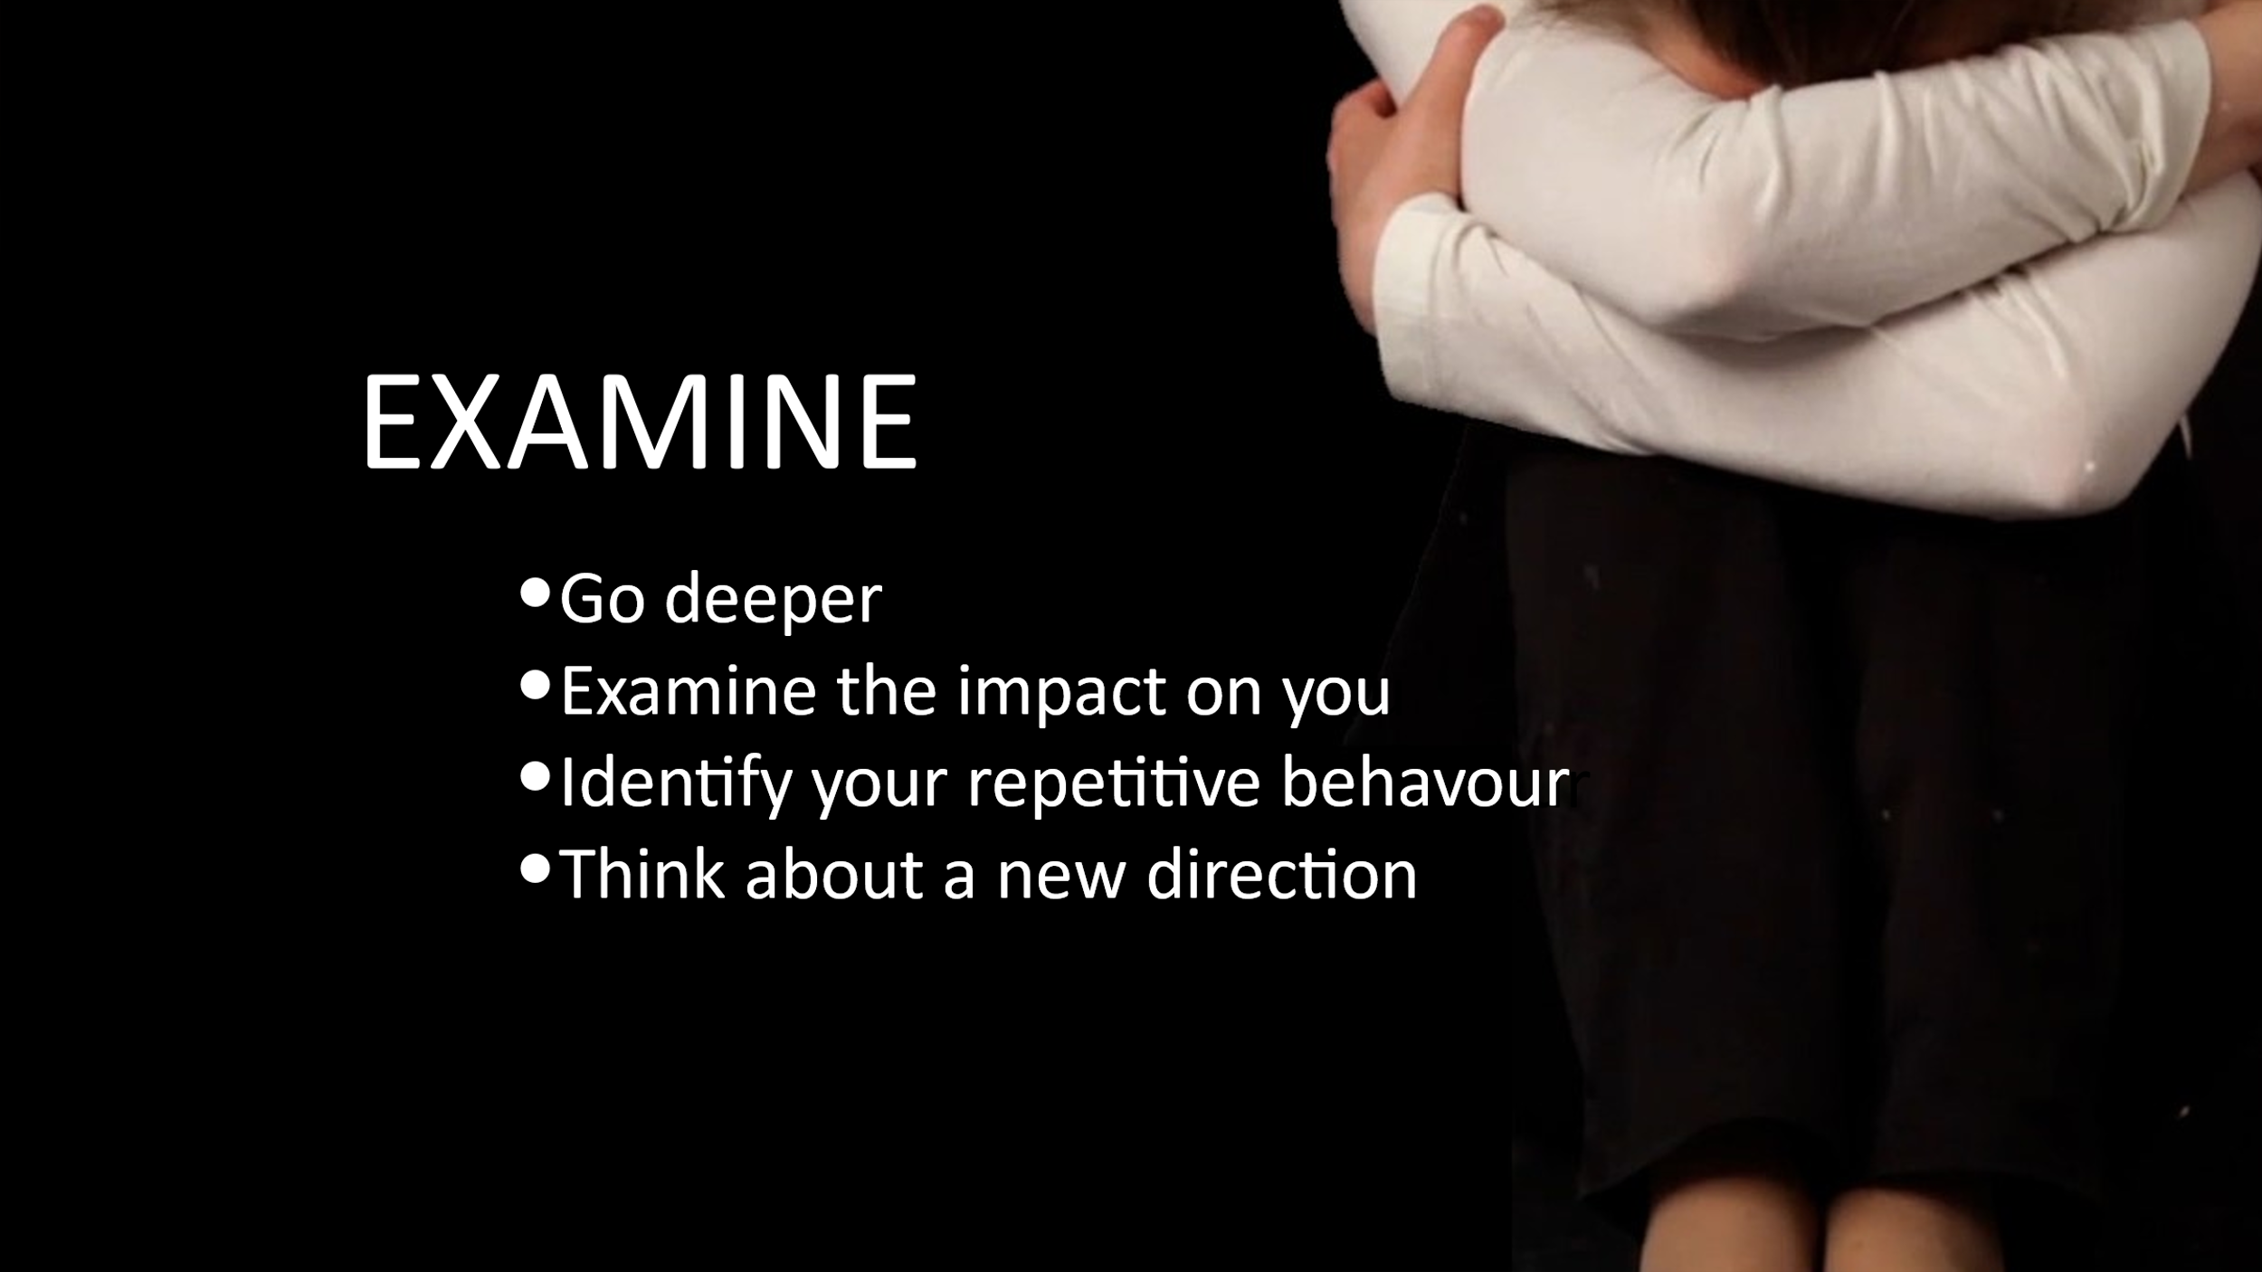

**EXAMINE the impact:**

By linking circumstances to emotions to repetitive behaviors, you are putting your glitch and its source under a microscope. YOUR UR PATHWAY begins to take shape (similar to Lorelie’s **(p. 271 and 272)**. Your responses from Part One “Getting to know Me” – ACE’s, sources of sad, and other factors - will populate automatically to make the links easily.

**What is the purpose of this?**

To discover: reasonable explanations for your repetitive thoughts and behaviors; the ‘glitch’ that has kept you stuck; and compassion for yourself.

YOUR PATHWAY (R1):

|  |  |
| --- | --- |
| **Consult Part One for concerns about relationships, childhood**  **circumstances, ACEs, trauma, things done or left undone, ‘sources of sad’** | **Emotions (list any that correspond with the circumstance to the left), especially ones you have been trying to avoid:**  **Grief, fear, anger, denial, sadness, shame, feeling unworthy of love or belonging** |
| *{should automatically populate}* | Participant adds this herself |
|  |  |
|  |  |
|  |  |
|  |  |
|  |  |
|  | *Continue on p. 15 if necessary* |

|  |  |
| --- | --- |
| **Consult Part One for concerns about relationships, childhood**  **circumstances, ACEs, trauma, things done or left undone, ‘sources of sad’** | **Emotions (list any that correspond with the circumstance to the left), especially ones you have been trying to avoid:**  **Grief, fear, anger, denial, sadness, shame, feeling unworthy of love or belonging** |
|  |  |
|  |  |
|  |  |
|  |  |
|  |  |
|  |  |
|  |  |
|  |  |

“I will Remember to:

“Allow the emotions. Embrace and make friends with sad. Let it wash over me. Find a safe, quiet place and carve out time for it. My adult’s heart has been broken. Perhaps my little girl’s heart was also broken in childhood or adolescence. Mourning, grieving, sadness, shame, anger and denial are all normal responses. But I soldier on and push it down. And later wonder why I don’t want to be alone with myself and my thoughts.

“Thoughts of being unworthy of love or belonging. Thoughts and memories of being abandoned or ridiculed or abused by people I trusted, who were supposed to provide stability and safety. Post traumatic stress. Fear that the things I witnessed, experienced, the things I did or did not do in the past make me unlovable.”

Tears and shouting at the ceiling, punching the pillows and trashing the cushions – all okay.

Notes:

Questions I want to ask:

(Next: Workshop #2 EXCAVATE)



**Guided Journal Part THREE –** “**EXAMINE”**

**Date:**

**First Mission the Week:**

Link the circumstances and emotions to your repetitive thoughts and behaviors. Maladaptive behaviors that undermine your ability to have a healthy relationship or find positive outcome.

Complete the dissection, put the thoughts and behaviors under the microscope

Avoid slogans (by being specific about your thoughts and behaviors)

Do more research, consult more experts

Go back farther, consider others’ circumstances

**Tools to Assist you:**

YOUR PATHWAY populated with circumstances AND emotions.

-column three allows you to link these with thoughts/behaviors

Lorelie’s examples: **READ UNLIMITED REVISIONS p. 269-273**

Soundtrack – SPOTIFY “Unlimited Revisions Soundtrack” may help you travel back in time to recall and relive the memories, “Dance” it out

Time with yourself in a safe space to travel back in time, reflect, journal

Support – feel free to reach out to a trusted friend, counsellor, other - talk it out

YOUR PATHWAY (R1)

|  |  |  |
| --- | --- | --- |
| **List any circumstances, ACEs, trauma from childhood, adolescent circumstances, things done or left undone, concerns about current/previous relationships and “Sources of your sad”** | **Emotions (list any that correspond with the circumstance to the left), especially ones you have been trying to avoid (e.g. grief, fear, anger, denial, sadness, shame, feeling unworthy of love or belonging** | **Repetitive thoughts behaviors that may have resulted from the circumstances.**  **From p. 10 and 11** |
| This column automatically populates | This column automatically populates | Participant adds these herself |
|  |  |  |
|  |  |  |
|  |  |  |
|  |  |  |
|  |  |  |
|  |  |  |
|  |  | *Continue on p. 19 if necessary* |
| **List any circumstances, ACEs, trauma from childhood, adolescent circumstances, things done or left undone, concerns about current/previous relationships and “Sources of your sad”** | **Emotions (list any that correspond with the circumstance to the left), especially ones you have been trying to avoid (e.g. grief, fear, anger, denial, sadness, shame, feeling unworthy of love or belonging** | **Repetitive thoughts behaviors that may have resulted from the circumstances.** |
| All columns Should populate automatically |  |  |
|  |  |  |
|  |  |  |
|  |  |  |
|  |  |  |
|  |  |  |
|  |  |  |
|  |  |  |

**2nd Mission:**

Excavating Worthiness

Begin a New Direction

Consider the “good” in your life – circumstances, experiences, things you did or refused to do – that POSITIVELY impact your feelings of worthiness.

Add the emotions these circumstances inspire

Link these to new thoughts and behaviors, ones that improve the likelihood of a healthy relationship with yourself and with others

**Tools to Help you:**

List of Risk and Protective factors

Lorelie’s examples: **READ UNLIMITED REVISIONS p. 274-275**

YOUR PATHWAY

[Risk and Protective Factors |Violence Prevention|Injury Center|CDC](https://www.cdc.gov/violenceprevention/aces/riskprotectivefactors.html) provides a list of many of these including:

some family members who create safe, stable and nurturing relationships (meaning a child has a consistent family life)

having positive friendships and peer networks

children who have positive school environment and flourish there, or with caring adults outside the family who serve as mentors/role models

families with caregivers that have support networks, that are consistently positive, enforcing rules, that work through conflicts peacefully, help the child to work through problems, engage in fun positive activities together and encourage the importance of school

communities that offer the same (support to families struggling with food insecurity, homelessness, that wraps around children in the community, offer programs and do not tolerate violence

Or you may have provided these for yourself in adulthood:

pursuing education

working hard to give yourself a safe, stable home

providing a safe, stable home to children (even if it’s not yours, seeking out help from family or friends)

seeking spirituality, meditation, exercise to improve your mental health

seeking lifelong learning about yourself, counselling, journaling

List any others:

Hold these up the light and acknowledge these factors as well.

**Linkages:** Complete YOUR PATHWAY (R2). This time examining things that *positively* impact feelings of worthiness!

|  |  |  |
| --- | --- | --- |
| **Consult your list from p. 21**  **Excavate any PROTECTIVE factors, the “good” in your life, things you did or refused to do (one per line)** | **Emotions (list any that correspond with the circumstance to the left)**  **e.g. Pride, satisfaction, feeling accomplished, fit, smart, competent**  **Feeling worthy. Living wholeheartedly** | **NEW thoughts and behaviors that may have resulted from the circumstances.**  **e.g. responding immediately and firmly to inappropriate male behavior; putting my safety first; letting myself be home alone and enjoying it** |
| *{automatically populates}* | This columns participant adds herself | This column participant adds herself |
|  |  |  |
|  |  |  |
|  |  |  |
|  |  |  |
|  |  | Continue on p. 23 if necessary |

|  |  |  |
| --- | --- | --- |
| **Consult your list from p. 21**  **Excavate any PROTECTIVE factors, the “good” in your life, things you did or refused to do (one per line)** | **Emotions (list any that correspond with the circumstance to the left)**  **e.g. Pride, satisfaction, feeling accomplished, fit, smart, competent**  **Feeling worthy. Living wholeheartedly** | **NEW thoughts and behaviors that may have resulted from the circumstances.**  **e.g. responding immediately and firmly to inappropriate male behavior; putting my safety first; letting myself be home alone and enjoying it** |
|  |  |  |
|  |  |  |
|  |  |  |
|  |  |  |
|  |  |  |
|  |  |  |
|  |  |  |
|  |  |  |

Notes:

Questions I want to ask:

(Next: Workshop #4 EXIT)



**Guided Journal Part FOUR: “EXIT”**

**Date:**

**This Week’s Mission:**

Learn the difference between the two pathways (R1 and R2)

Exit the UR Pathway with:

* *wholeheartedness!*
* *compassion* for yourself (and perhaps others)!
* a *manifesto* (a written mission statement for yourself) with explicit expectations for yourself and your future.
* *Vigilance* that helps you take notice when repetitive thoughts, behaviors, reactions (heart-pounding) creep up. *Strength* to examine them, and “check yourself”. *Bravery* to pursue the crucial conversations you used to avoid.
* *confidence* because you know you will not repeat history! Instead, you will pursue a new outcome.
* *Support* from friends and your Sisters In Recovery!

**Tools to Help You:**

Review YOUR PATHWAY, R1 and R2

Lorelie’s examples **READ UNLIMITED REVISIONS p. 257-258**

**READ UNLIMITED REVISIONS pages 269-273**

Role-playing different scenarios

Plans for ongoing support

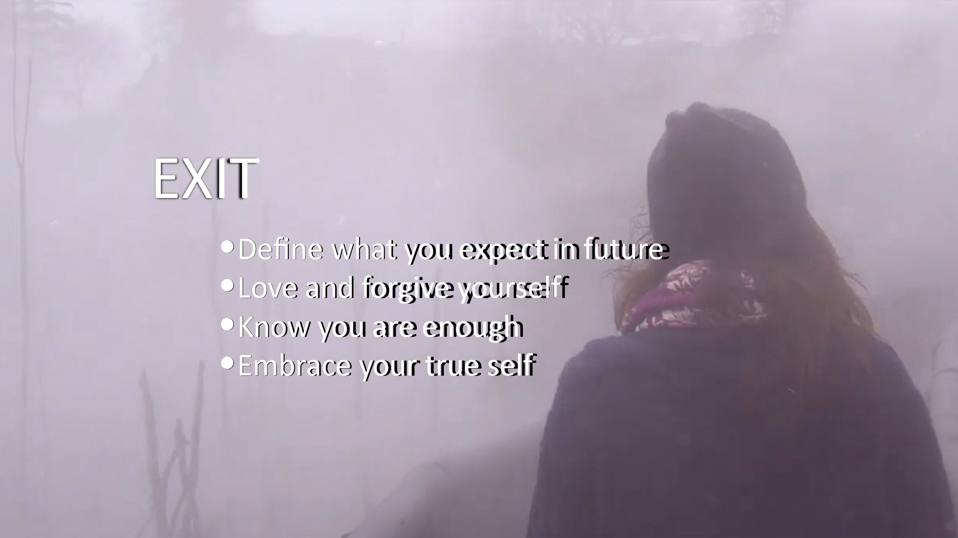

Journalling exercises – try writing a paragraph for each point

Who you were (be explicit!) and remember: LOVE HER! (she was doing her best!!):

Who you are now/want to be: *This is the manifesto – your newest, best-est version of yourself (Lorelie version 7.7)* – Be explicit! Be Specific!

Your explicit expectations for yourself in the future: include your dreams, aspirations, ambitions….

Your explicit expectations in intimate relationships: include what you will/will not tolerate, accept, encourage or discourage from family members, partners….

**Consider scenarios:** list potential conflicts that you anticipate in relationships, and how you plan to address them (think *crucial conversations,* or *escape plans,* also *deal-breakers)…..*

Examples from previous participants: conflict over kids (yours, your new partner’s, co-parenting with ex, different parenting styles), drug/alcohol-use, merging (households, resources) or not, etc.

List Scenarios:

**Consider your past repetitive thoughts/behaviors** and how they could be ‘triggered’ (as in, you find yourself responding the same way, repeating history, even in a different relationship or situation)….

List triggers, thoughts, behaviors:

**Roleplay:**

**Sisters In Recovery…. Ongoing Self-Love Maintenance Plans:**

Notes:

Questions to Ask: